EUROPEAN RALLY TROPHY – FINAL

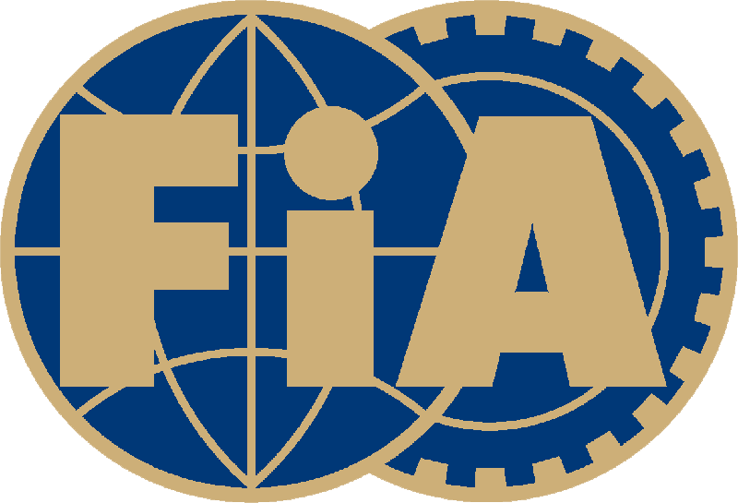NOV
RALLYE WALDVIERTEL 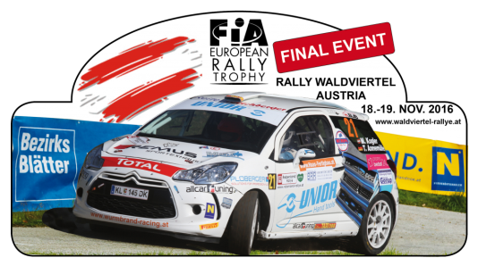
18. – 19. November 2016

FIA Finale ERT:
1. Rashid Alketbi (ARE/Ford Fiesta R5)
2. Krisztian Hideg (HRV/Mitsubishi Lancer Evo IX)
3. Björn Satorius (DEU/Subaru Impreza WRX)
FIA Finale ERT2 TROPHY:
1. Krisztian Hideg (HRV/Mitsubishi Lancer Evo IX)
2. Björn Satorius (DEU/Subaru Impreza WRX)
3. Sergej Remennik (RUS/Miotsubishi Lancer Evo X)
FIA Finale ERT3 TROPHY:
1. Filip Mares (CZE/Peugeot 208 R2)
2. Marty Gallagher (IRL/Peugeot 208 R2)
3. Grega Premrl (SVN/Citroen DS3)
FIA Finale ERT JUNIOR TROPHY:
1. Filip Mares (CZE/Peugeot 208 R2)
2. Marty Gallagher (IRL/Peugeot 208 R2)

